**PI EP – PI_Analysis-ErrorPathExtractor**

**User Guide**

## VERSIONING AND CONTROL VALIDATION

VERSIONING HISTORY

|  |  |  |  |
| --- | --- | --- | --- |
| Version | AUTHOR | REVISION | Date |
| 1.0 | Geoffrey Pignet | First review | 02/05/2022 |
|  |  |  |  |
|  |  |  |  |
|  |  |  |  |
|  |  |  |  |
|  |  |  |  |

VALIDATION

|  |  |  |
| --- | --- | --- |
| Version | Name | Date |
| 1.0 |  |  |
|  |  |  |

## DOCUMENT CONTENT

1. VERSIONING AND CONTROL VALIDATION 2

2. DOCUMENT CONTENT 3

3. SCRIPT DESCRIPTION 4

3.1. Objective 4

3.2. Prerequisite 4

4. USER GUIDE 5

4.1. Prepare the input file 5

4.2. Run the script 5

## Script description

**3.1 Objective**

**The purpose of this script is to recover the paths to the analyzes in error in order to send them in a clear and detailed file to the end users who will be able to find and correct these errors more easily.**

**3.2 Prerequisite**

* Microsoft Powershell (1.0 or later)
* Access to analysis server to retrieve the logs

## User guide

### Prepare the input file

In the folder **C:\ProgramData\OSIsoft\PIAnalysisNotifications\Logs** of the AF server, copy the logs from the file “**pianalysisprocessor-log**”,

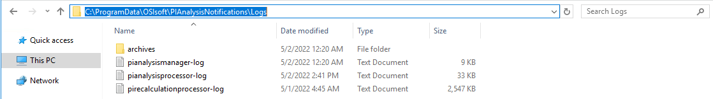

and paste them into the Input\input.txt file (delete existing text if necessary). Save and close the file.

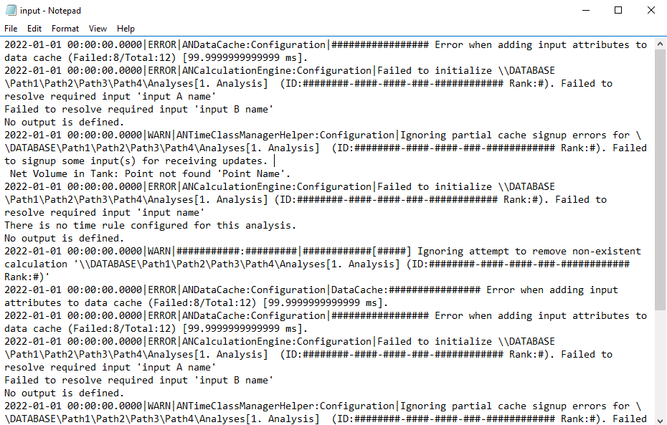

### Run the script

**Right-click on the script.ps1 file, and click on « run with Powershell »**

You should have all the paths and descriptions of analyzes in error in Output/output.csv file.

